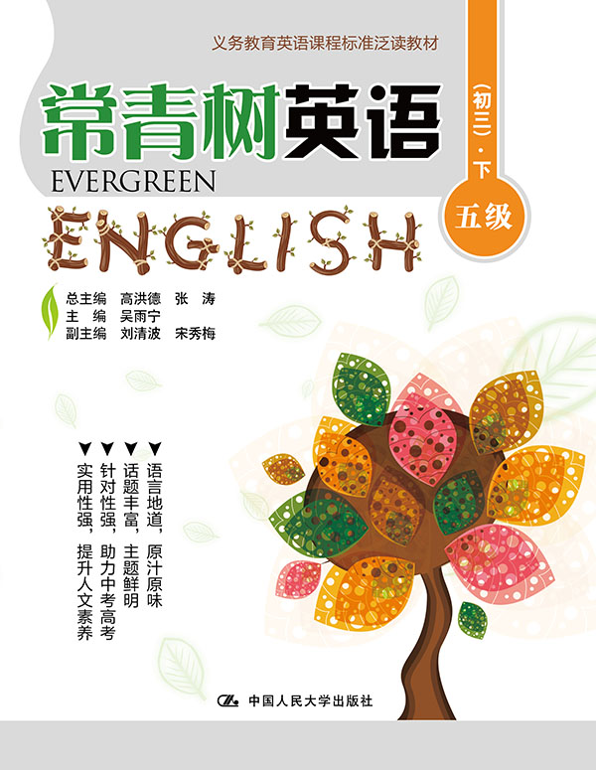
书名：常青树英语 五级（初三）·下
书号：978-7-300-21866-3
作者：高洪德 张涛 吴雨宁
责任编辑：鞠方安 郭亚光
成品：177*228 页数：279
纸张：70克高白胶
装祯：平装
出版时间：2015年9月
定价：49.00元
出版社：中国人民大学出版社

- 本书卖点
- 语言地道、原汁原味
- 话题丰富、主题鲜明
- 针对性强、助力中考高考
- 实用性强、提升人文素养

◆ 读者定位
初中生

- 作者简介
高洪德，山东省教学研究室英语教研员、特级教师，中国教育学会外语教学专业委员会副理事长、山东省教育学会外语教学研究专业委员会理事长。
张涛，山东省教育学会外语教学研究专业委员会秘书长、山东省教学研究室英语教研员。

- 内容简介
《常青树英语 五级（初三）·下》的编写遵循了《义务教育英语课程标准》的要求，符合中国英语教学实际，难度上契合我国初中（三年级）学生的英语学习现状。全册以课程标准24个话题为主线，材料的选取与现行教材的话题相匹配。五级上册每篇控制在150~700词。每篇文章前面都有阅读导语，以引起学生的阅读兴趣，并配有生动有趣的插图。课后配有多样化的学习任务。

◆ 简要目录
Lesson 1 Traffic safety for children
Lesson 2 Road trip
Lesson 3 Travel records
Lesson 4 Why are you always busy?
Lesson 5 Dreams
Lesson 6 What to do during summer holiday?
Lesson 7 Holiday in Britain and the US
Lesson 8 Death Valley National Park
Lesson 9 Camping in America's National and State Parks
Lesson 10 Shopping Tips
Lesson 11 Shopping for jewelry
Lesson 12 Teleshopping in Europe
Lesson 13 Different shopping experiences between a man and a woman
Lesson 14 The Great PK between Chinese and Western Dietetic Culture
Lesson 15 You are what you eat
Lesson 16 Eating Custom and Practice
Lesson 17 Fruit in America
Lesson 18 Laughter is the best medicine
Lesson 19 Mental health is everyone's business
Lesson 20 What will man be like in the future
Lesson 21 How to succeed in your online language exchange
Lesson 22 How to learn English well?
Lesson 23 Mary Kay
Lesson 24 Make a good plan
Lesson 25 My Mouth
Lesson 26 Echo
Lesson 27 Speak out Your Love
Lesson 28 A father's letter to his son
Lesson 29 The real pearl necklace
Lesson 30 Weather affects health, intelligence and feelings
Lesson 31 Pollution
Lesson 32 The Colors of the Rainbow
Lesson 33 The importance of positive reinforcement
Lesson 34 Sports day
Lesson 35 E-sports
Lesson 36 Alien at School: Aliens (Excerpt)
Lesson 37 Fire alarm test in England
Lesson 38 Advantages of Playing Games for Children
Lesson 39 Running out of water!
Lesson 40 Something about dinosaurs
Lesson 41 How much do you know about peacocks?
Lesson 42 Stay safe when playing sports
Lesson 43 Fire safety
Lesson 44 The Earth is getting warmer
Lesson 45 Slow down the process of global warming
Lesson 46 A Teenage Social Activist
Lesson 47 Abraham Lincoln Didn't Quit
Lesson 48 A Lesson From A Son
Lesson 49 Run, Patti, Run
Lesson 50 No One But Yourself Can Defeat You
Lesson 51 The Sunshine Man
Lesson 52 "Looking Pleasant"–Something to be Worked from The Inside
Lesson 53 Catch up with Your Good
Lesson 54 My Father, My Hero
Lesson 55 My Dear Parents
Lesson 56 Looking for Friends
Lesson 57 An Unforgettable Friend
Lesson 58 A Great Mother
Lesson 59 Health of the Body (1)
Lesson 60 Health of the Body (2)
Lesson 61 Health of the Body (3)
Lesson 62 The Blind Man and the Elephant
Lesson 63 Birds in Summer
Lesson 64 A lesson for Living
Lesson 65 Baseball and Henry Wiggen
Lesson 66 A Big Lesson during My Childhood
Lesson 67 Mother's Hand
Lesson 68 I am a Tomboy
KEY

◆ 上架建议
中学英语泛读读本

书摘
Lesson 1 Traffic safety for children
Guidance
What’s the most important thing of traffic? You know, it must be safety. How to be safe in the car for children? 交通，最重要的事情是什么？你懂的，肯定是安全。对于孩子来说如何才能保证安全呢？

Most cars have safety belts as part of their equipment. Safety belts protect drivers and passengers in the accident. Safety experts say that safety belts save thousands of lives a year in the United States alone and up to a million people in the world.
Recently a new study in America shows that many people do not appropriately use safety belts for children in cars.
The researchers found that 21% of children younger than 4, 33% of 4-year-old and 5-year-old, and 66 % of 6-year-old and 7-year-old, were not using safety belts.
The situation is very serious, because children may hit the seat in the car or fly out of it when the car is running. But many parents don’t care about it. If they were driving with four or more children in the car, the parents often forget to restrain their children.
To our joy, new rules about wearing safety belts have been published. It requires that children under 4-year-old should use safety belts. Most of people believe the new rules will work.
Otherwise, some people think using the child safety seat is a good idea. The child safety seat is now popular in the world. It makes the children comfortable and safe in the running car. But media have reported that many parents misused the child safety seat and very often caused the casualties of the infants. The Child Safety Foundation pointed out that the risk of not appropriately using the child safety seat is eight times higher than that of appropriately using the child safety seat. The Foundation says that parents should always use the child safety seat in an appropriate way. Do not hold the children sitting in the front seat or car backseats.

